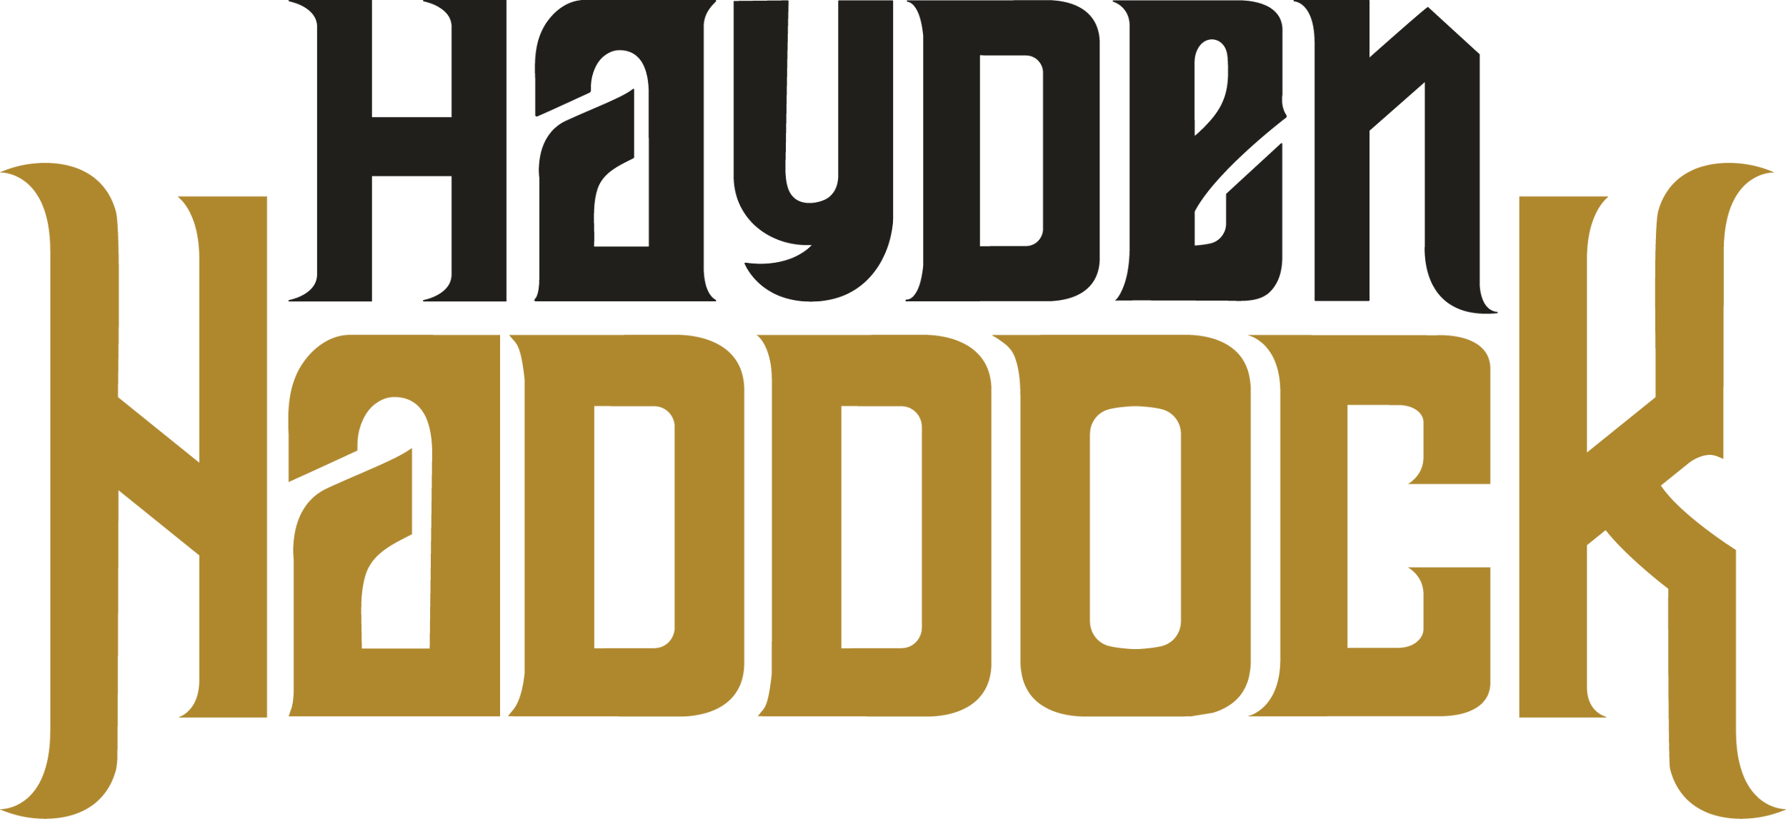

Texas-based singer-songwriter, Hayden Haddock is on the fast track to becoming a mainstream country recording and touring artist.

The Texas A&M graduate’s music career catapulted in 2018 when an impromptu video performance, shot in his college dorm, surfaced online. The construction science major was quick to establish a loyal following garnering more than 1.4 million YouTube views and 90K fans across all digital platforms. Over the course of seven short years, the hardworking, road warrior has become an active member of the songwriting community, writing with countless hit songwriters (Trent Willmon, Tommy Karlas, John Pierce and Jim Collins among others). He performs nearly 100 dates a year across the U.S. taking the stage as support act for Randall King, Randy Rogers Band, Steve Wariner, Diamond Rio, Braxton Keith, Mark Chesnutt, Easton Corbin, Tracy Lawrence and more. Hayden has enjoyed feature spotlights in Billboard, Taste of Country, The Boot, Country Now, Country Rebel, and Texas Lifestyle Magazine, notably and made a number of television appearances. In 2021, he was named “New Male Vocalist of the Year” by the Texas Regional Radio Music Awards (T3R).

Revealing nuances of the Texan’s musical influences (George Strait/Tracy Lawrence/Cody Johnson/Clay Walker), Hayden has celebrated seven tracks on the Texas radio charts with four reaching the Top 10; he earned his first No. 1 on the Texas Country Music Chart in 2025 with his single, “Front Porch In the Rain.”

Boasting more than 12 million streams to date, Hayden’s recordings have been spotlighted on multiple playlists including “Texas Music Now” (Spotify), “Fresh Finds Country” (Spotify), “Texas Music Rewind” (Spotify), “Don’t Mess With Texas” (Apple Music) and “Texas Forever” (Amazon Music). He is signed with Good Company Entertainment for management representation.

His new single, "Hell or High Whiskey" (November 2025) is keeping with the artist’s previous style and recordings. Haddock has a string of singles anticipated to be released throughout 2026.

Diagnosed with Type 1 diabetes as a youngster, Hayden has worked with several organizations to enhance awareness surrounding the disease; he has been an advocate/speaker for the Breakthrough T1D (Formerly JDRF), an international, non-profit organization dedicated to raising funds to support and promote diabetes research as well as other Type 1 Diabetes camps/organizations.

CONNECT:
WEBSITE
INSTAGRAM
SPOTIFY

